Riley Air Control Systems Pty Ltd
MFD Series

Motorised Fire / Smoke Dampers

4 Hours Fire Integrity Rating

Heavy Duty - for wall & floor mounting application

SPECIFICATION DATA

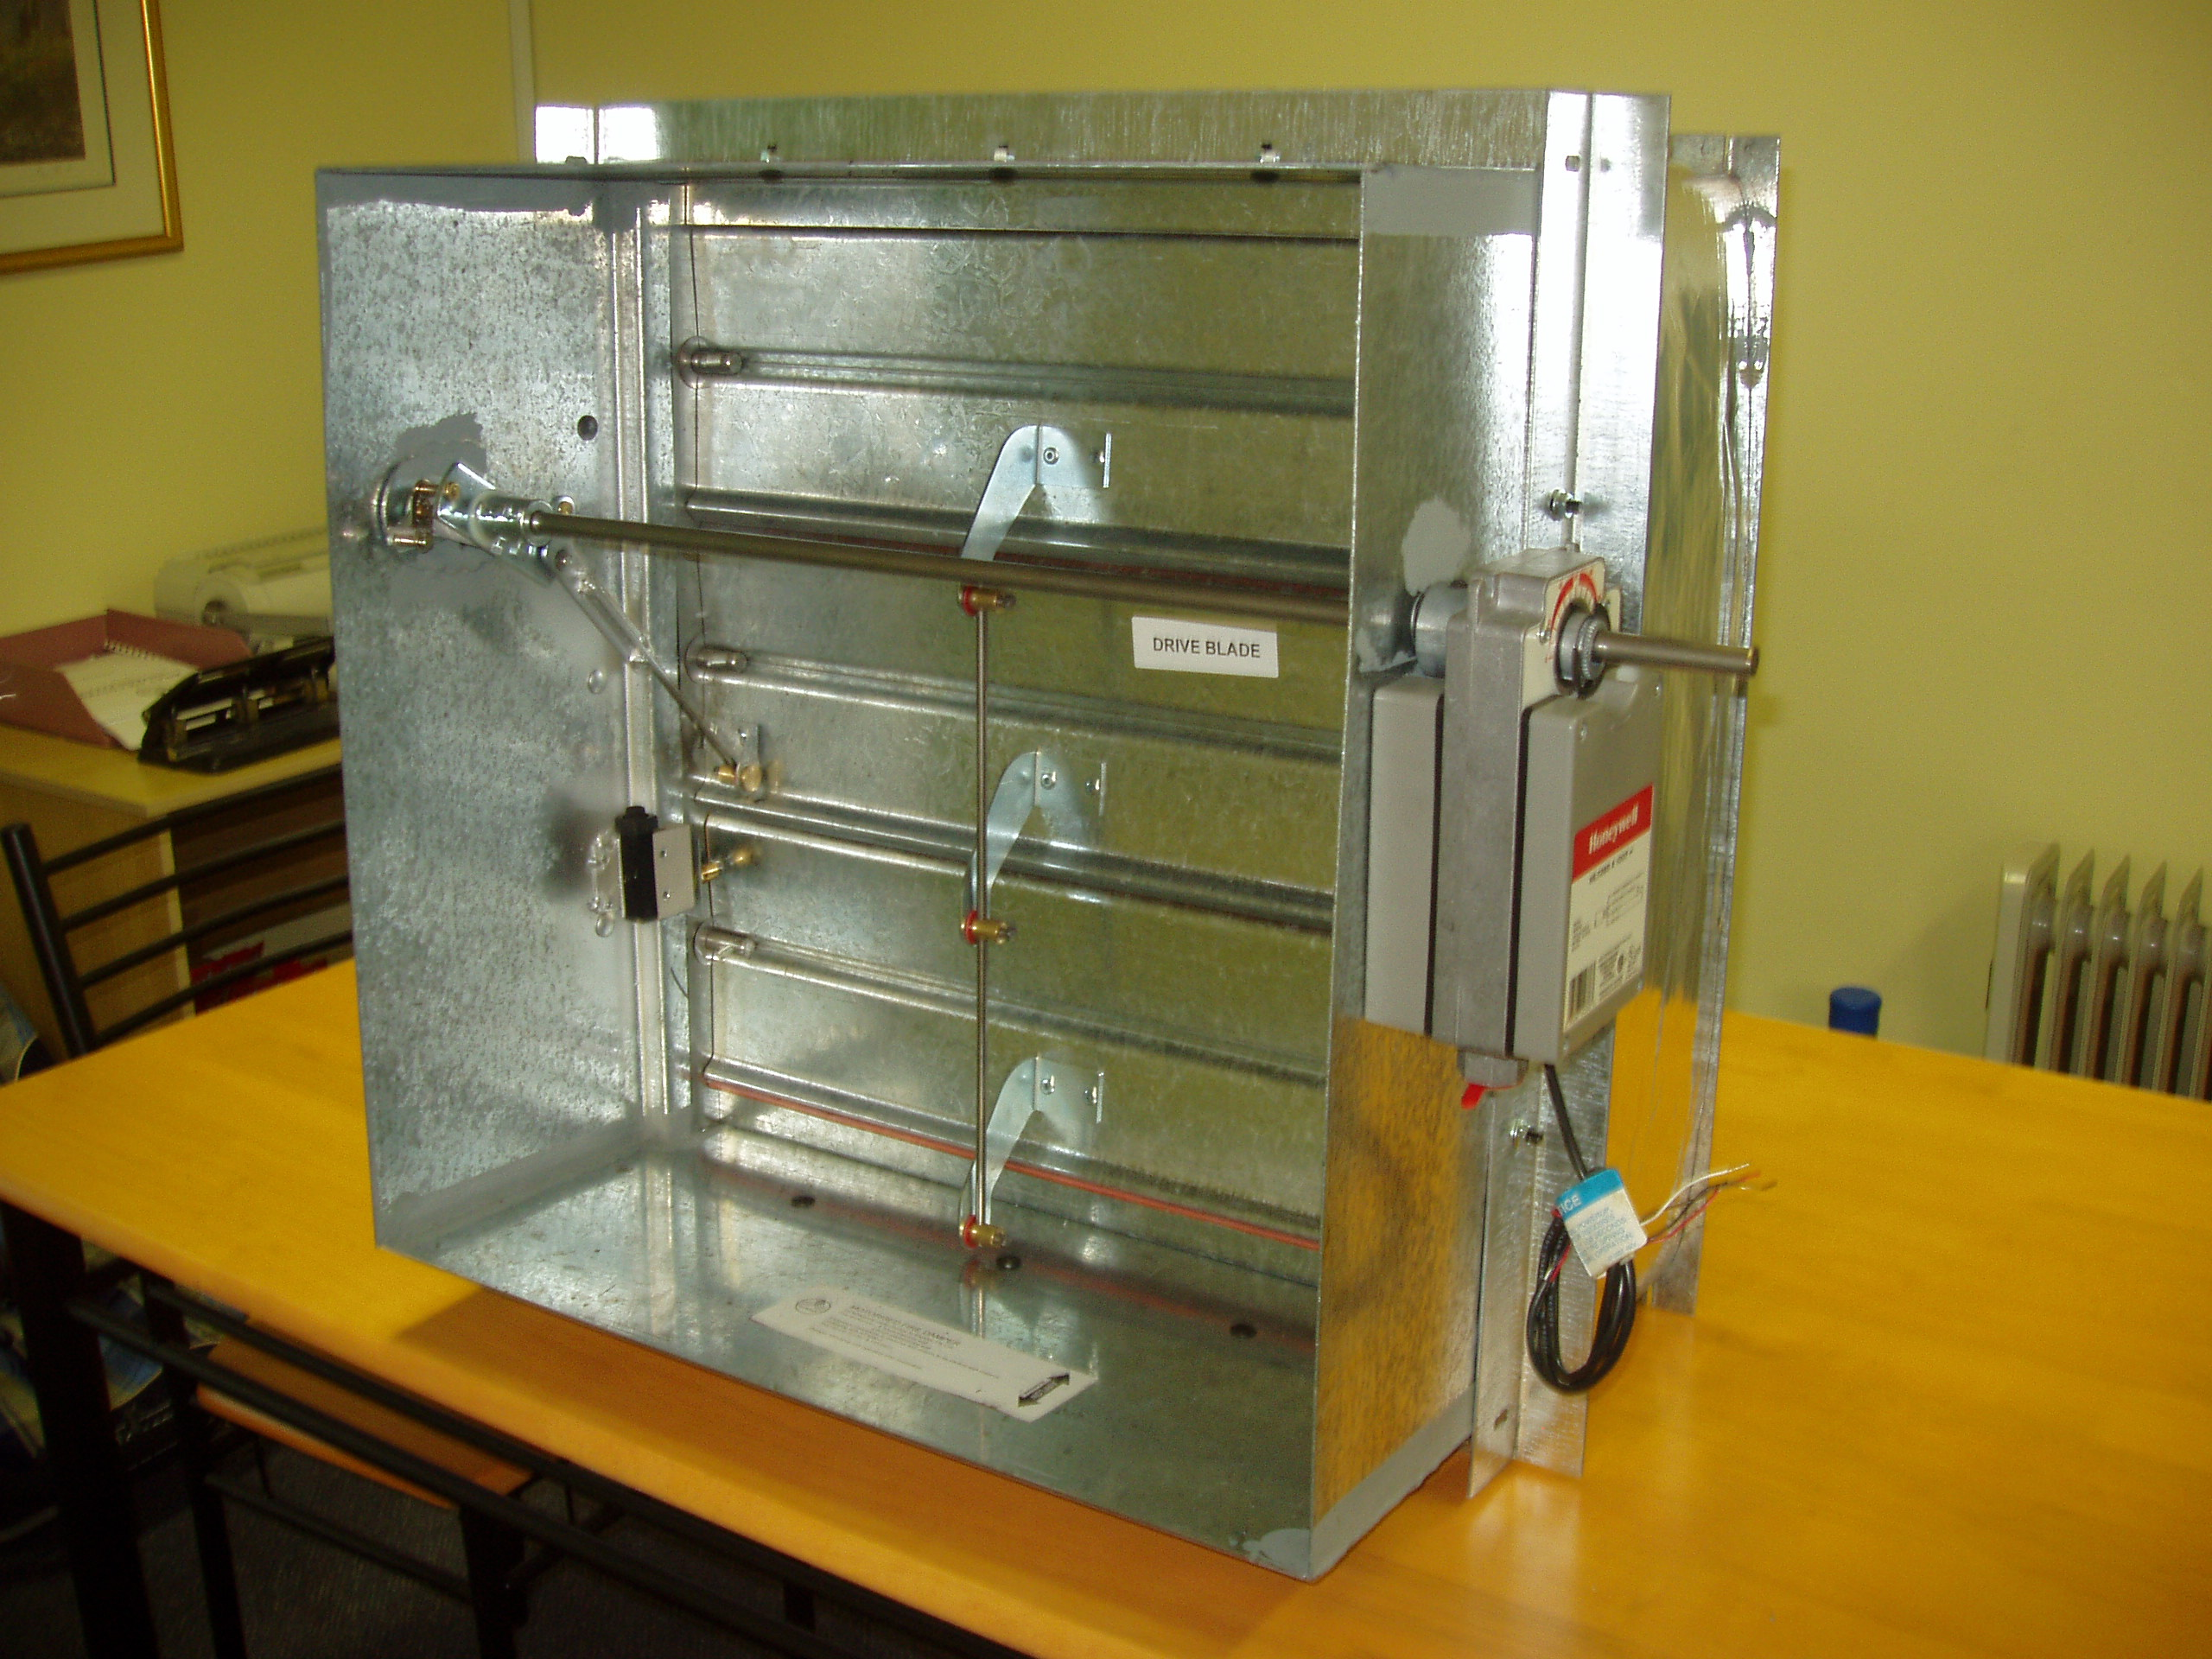
General  The Blendair Motorised Fire/Smoke Damper Series MFD is a HEAVY DUTY damper, designed to provide efficient airflow control and to impede the spread of fire and / or combustible products (e.g. smoke) through wall openings to other fire compartments of an air-handling system.  This range of Motorised Fire/Smoke Dampers finds its application in building construction and mining industry where ventilation, heating, cooling or air-conditioning systems are employed.  The design concept is based on an interlinked set of blades connected with a solid drive shaft using a standard pneumatic actuator or electric-electronic fail-safe spring return actuator with a fusible link incorporated into closing mechanism and link arm holding the blades in the closed position after closure. |  | Features  - Rugged construction  - Tight manufacturing tolerances  - High strength and repeatable quality of roll-formed and fully welded frame  - Non-corrosive blade bearings  - Stainless steel side seals.  - Silicone tip seals.  - Suitable for masonry dry wall and slab mounted application  - Adjustable mounting angles  - Suitable for multi-module installation  - Blendair Motorised Fire Dampers meet & are manufactured to Australian Standards 1682 and 1530 requirements.
MFD Series Motorised Fire/Smoke Damper
DESCRIPTION & FUNCTION  The Blendair Motorised Fire/Smoke Damper Series MFD is designed to impede the spread of fire and or combustible products (e.g. smoke) and to provide efficient airflow control in the air handling system. The design principle is based on an interlinked set of blades connected with a solid drive shaft using pneumatic actuator with a fusible link incorporated into the closing mechanism and a stainless steel spring holding the blade in the closed position after closure. The damper is installed in a wall or slab opening separating two fire compartments of an air-handling system with the blades housed within the damper frame, and when closed sealing against a rebate of the casing. The casing is of press-formed galvanized steel construction. Low friction internal blade linkages and blade bearings ensure low torque and smooth and efficient modulation operation. |  | DAMPER SIZING SPECIFICATION  Modules are supplied in the following standard sizes:  Single Module: from 150mm x 150mm (min)  to 1200mm x 1200mm (max)  Size Increment: as required  Multi Modules: max size 2400mm x 900mm  Important Notes:  - When specifying damper sizes (width and height), provide duct size dimensions! No allowance made.  - When specifying wall opening sizes, allow sufficient space for insulation and expansion, use the following  External damper size + 10mm + 1% of linear length (width/height)
Adjustable mounting flanges hold the complete damper assembly securely in the wall opening, with appropriate insulating material packed into the clearance space to meet installation standards. The opening, closing or modulation of the interconnected blades is affected by electric or pneumatic actuators initiated by control signals and closure by the breaking of the thermal fire link when temperature in the air system reaches the rated thermal limit. |  | 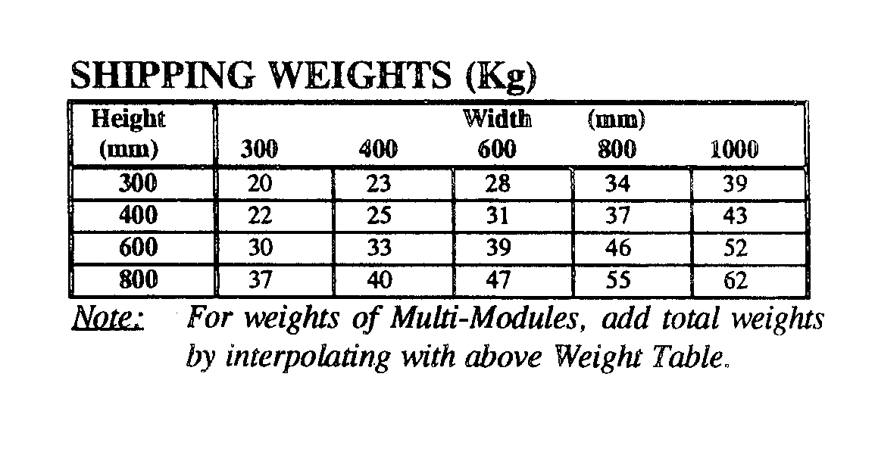
MODEL  - MFD: Motorised Fire/Smoke Dampers for  installation in brick or concrete walls for  horizontal airflow with 4 Hours Fire  Integrity Rating and for Installation dry  walls for 2 hours fire integrity rating  GUIDE SPECIFICATION (for the Engineer)  Motorised Fire/Smoke Dampers installed shall be of design and construction as supplied by Blendair which meet the requirements of Australian Standards 1682- AS 1530. The damper frame shall be of roll-formed and welded galvanized steel construction to minimize distortion during transit and to maintain square ness during installation. The galvanized steel blades shall be interlinked and pivoted by special stainless steel shaft and bronze bearing assemblies. The damper must guarantee accuracy and consistent closing operation. |  | SPECIFICATIONS - Construction  Materials & Finishes:  - Damper frame, blades and mounting angles made of zinc-coated (“galvanized”) steel sheet, complying with AS 1397 with a coating class not less than Z275.  - Damage to the zinc-coating, e.g. through welding, is remedied by appropriate cleaning method and application of special ‘galvanizing’ paint.  - Stainless steel version available as an OPTION.
MFD Series Motorised Fire/Smoke Damper
Damper Frame:  Press-formed galvanized steel, fully welded at all four corners, with 6x12 mm rounded slots punched into casing to allow for variations in wall thickness. |  | SPECIFICATIONS - Technical  Operation:  Damper closing is initiated by a pneumatic actuator or
  Damper Blades: |  | electric- electronic fail-safe spring return actuator or the breaking of the thermal fire link, when temperature in the air stream reaches rated thermal limit. The horizontally held interlinked set of blades will close forming a tight barrier and impede the spread of fire
Press-formed galvanized steel with special joggle lips pressed into blade ends to allow perfect overlap of blades and sealing. |  | and/or combustible products to other compartments of the air-handling system.
  Blade Orientation/Location: |  | Damper Closing Temperature:  - Standard Fire Link: 74 degree C (nominal)  - Special Thermal Links or Closing Actuation Devices can be fitted, providing compliance with Standards.
Horizontal: Individual blades are centre pivoted and interlinked via blade linkages and linkage rod |  | Maximum Air Velocity:  IMPORTANT! It should be avoided to install Motorised Fire Dampers near the supply fan which may
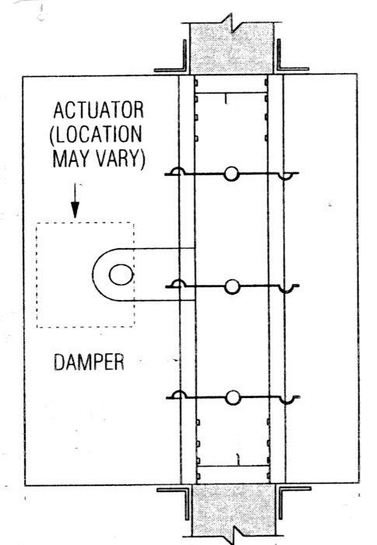  Mounting Angles: |  | cause blade flutter and thus excessive wear of blade bearings.  Max. Velocity: 8m/s (without pressure relief fitted)  13 m/s (with pressure relief fitted)  Note: Above values are recommendations from experimental tests carried out by CSIRO  Air-Flow Orientation:  Bi-Directional.
Roll-formed 2.0mm ‘right angle’ brackets with 6x12 mm slots at 150 mm pitch to allow for variations in wall thickness.  Shafts & Bearings:  Stainless steel shafts with bronze bushes.  Thermo-Link:  The thermo-link is a ‘once only’ used  - Standard: Fusible Solder Link (74 degree C)  - Non standard: Electric Resettable Link (74 degree C) ERL.  Actuators:  Wherever possible actuators should be external for ease of electrical connection, testing and service. Internal mounting should only be used where dictated by space constraints and cannot be avoided. There are limitations on smaller damper sizes. It should also be realized that internal actuator mounting on smaller dampers may significantly reduce the duct free area and therefore, increase pressure drop. These dampers require more torque to operate than conventional Motorised dampers. Selection of an actuator should take this into consideration |  | Standards Approval Listing:  MFD Motorised Fire/Smoke Dampers have passed the test to meet the Leakage and Fire Integrity requirements of AS 1530 and AS 1682 with the dampers exposed to ~ 1100 degree Celsius for 4 hour period in masonry wall a for 2 hour period in dry wall and 4 hour period in concrete slab.  Copies of SA Certificates may be supplied on request.  Access to Thermo-Link:  From motor side only.  Mounting Hardware:  Zinc plated ¹/₄ inch cup head bolts, nut and washers for each set of slotted mounting holes in frame & mounting angles.
MFD Series Motorised Fire/Smoke Damper
INSTALLATION  IMPORTANT: The installation of Motorised Fire/Smoke Dampers must comply with the requirements of AS 1682, Part 2. Deviation from any Clause of the Standards must be approved by a Regulatory Authority!  Basic Regulations:  - Dampers shall be installed in the fully open position only! No intermediate blade position is allowed!  - Damper frame (casing) must fully penetrate the wall or slab opening.  - Pivot point of damper blades must be fully contained within the penetrated wall or slab element.  - Clearance between wall opening and damper body (frame) must be such to allow adequate of insulating material, PLUS expansion factor for fire situation. Recommended clearance formulae: 5 mm + ¹/₂ % of linear length dimension (width/height)  - The clearance space between the damper and the penetrated wall opening must be fully packed with approved insulating material to prevent free flow of combustible materials (e.g. smoke). Material must maintain fire integrity up to 1000 degree C.  - Mounting Flanges must cover the clearance (2x clearance). Contractor may have to fit larger flanges if clearance exceeds recommended sizes.  - Ensure that access to damper is provided for maintenance purposes (e.g. access panel in duct).  - Install damper according label instruction.  Other Installation Hints:  - Remove one set of mounting flanges from one side of damper.  - Insert damper into wall or slab opening.  - Pack clearance space between damper casing and wall opening with insulating material to meet above requirements.  - Re-fit mounting flanges, nuts & bolts to damper and tighten, ensuring that flanges are butting tight against the wall or slab and that damper is fitted squarely.  - Ensure that damper closure is not impeded by any obstruction, incorrect installation (e.g. twisted, out of square), damage to damper or contamination to blade bearings (e.g. building dust).  - Check proper closing operation.  - When fitting duct ensure that appropriate damper sleeve connections are used to allow proper duct ‘breakaway’ in a fire situation (refer AS 1682, part 2 - Appendix B: Examples).  - Ensure that adequate access panel is fitted to duct to allow easy maintenance to damper. |  | OTHER DAMPER PRODUCTS  - Fire dampers:  Curtain Fire Damper, Single Blade Fire Damper, Circular Fire Damper, Volume Fire Damper, Ceiling Fire Damper  - Volume Control Dampers:  Low Leakage Volume Damper (standard), Ultra Low Leakage Volume Damper, High Performance Volume Damper, Min/Max Damper, Face & Bypass Damper, Zone Damper, Non-Return & Barometric Damper  - Sub Ducts  - Damper Actuators & Accessories

Head Office: Riley Air Control Systems Pty. Ltd.
3/78-80 Bellingara Road
Miranda NSW 2228
Phone: (02) 9544 8854
Email: info@rileyair.com.au

