Riley Air Control Systems Pty Ltd.

VDA Series

High Performance/Aluminium

Volume Control Dampers

SPECIFICATION DATA

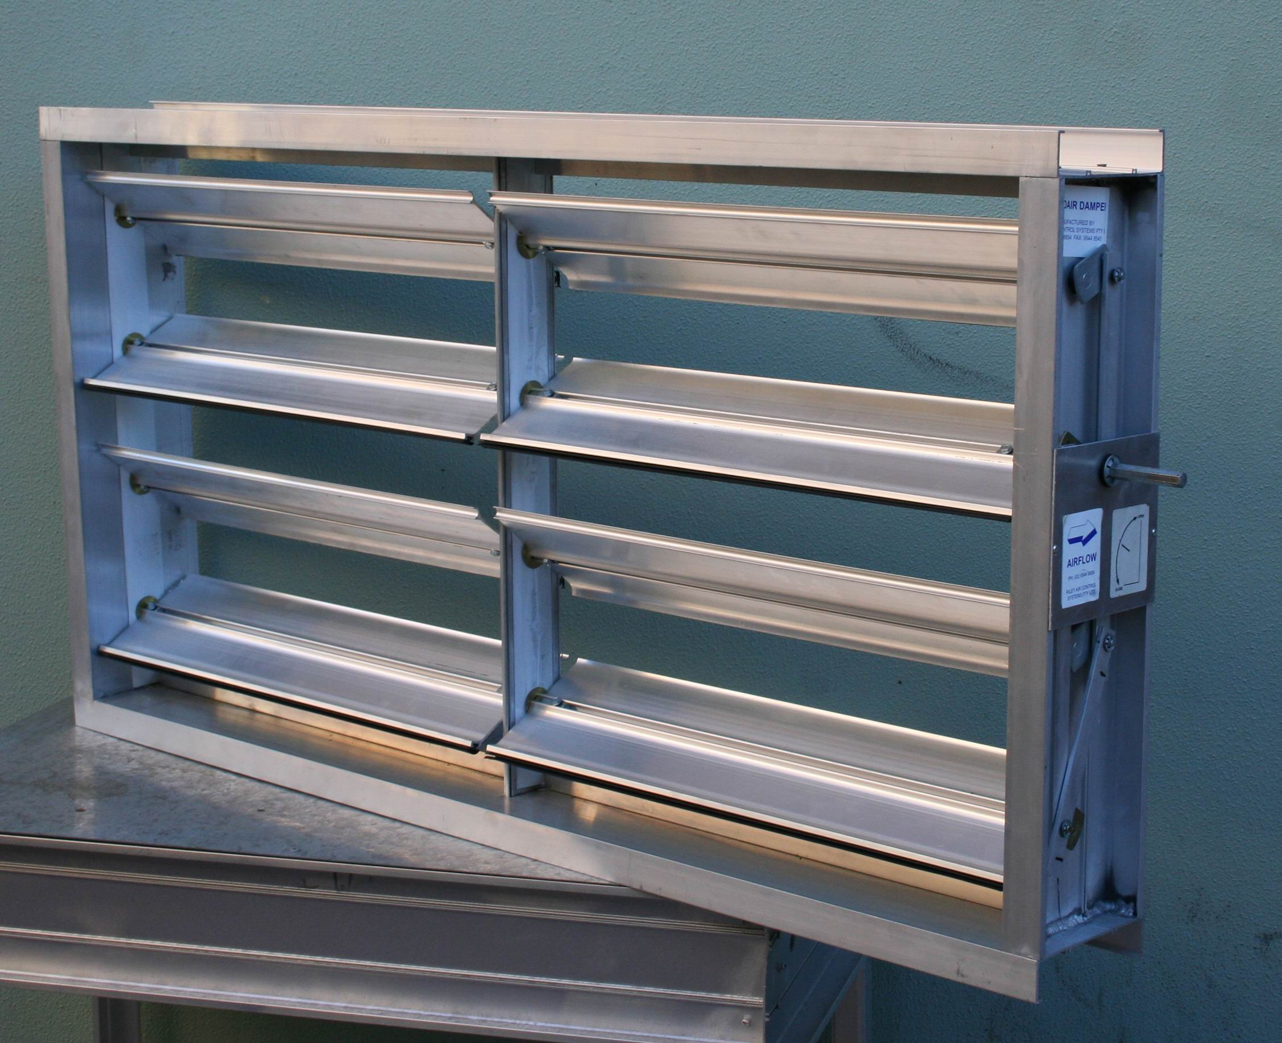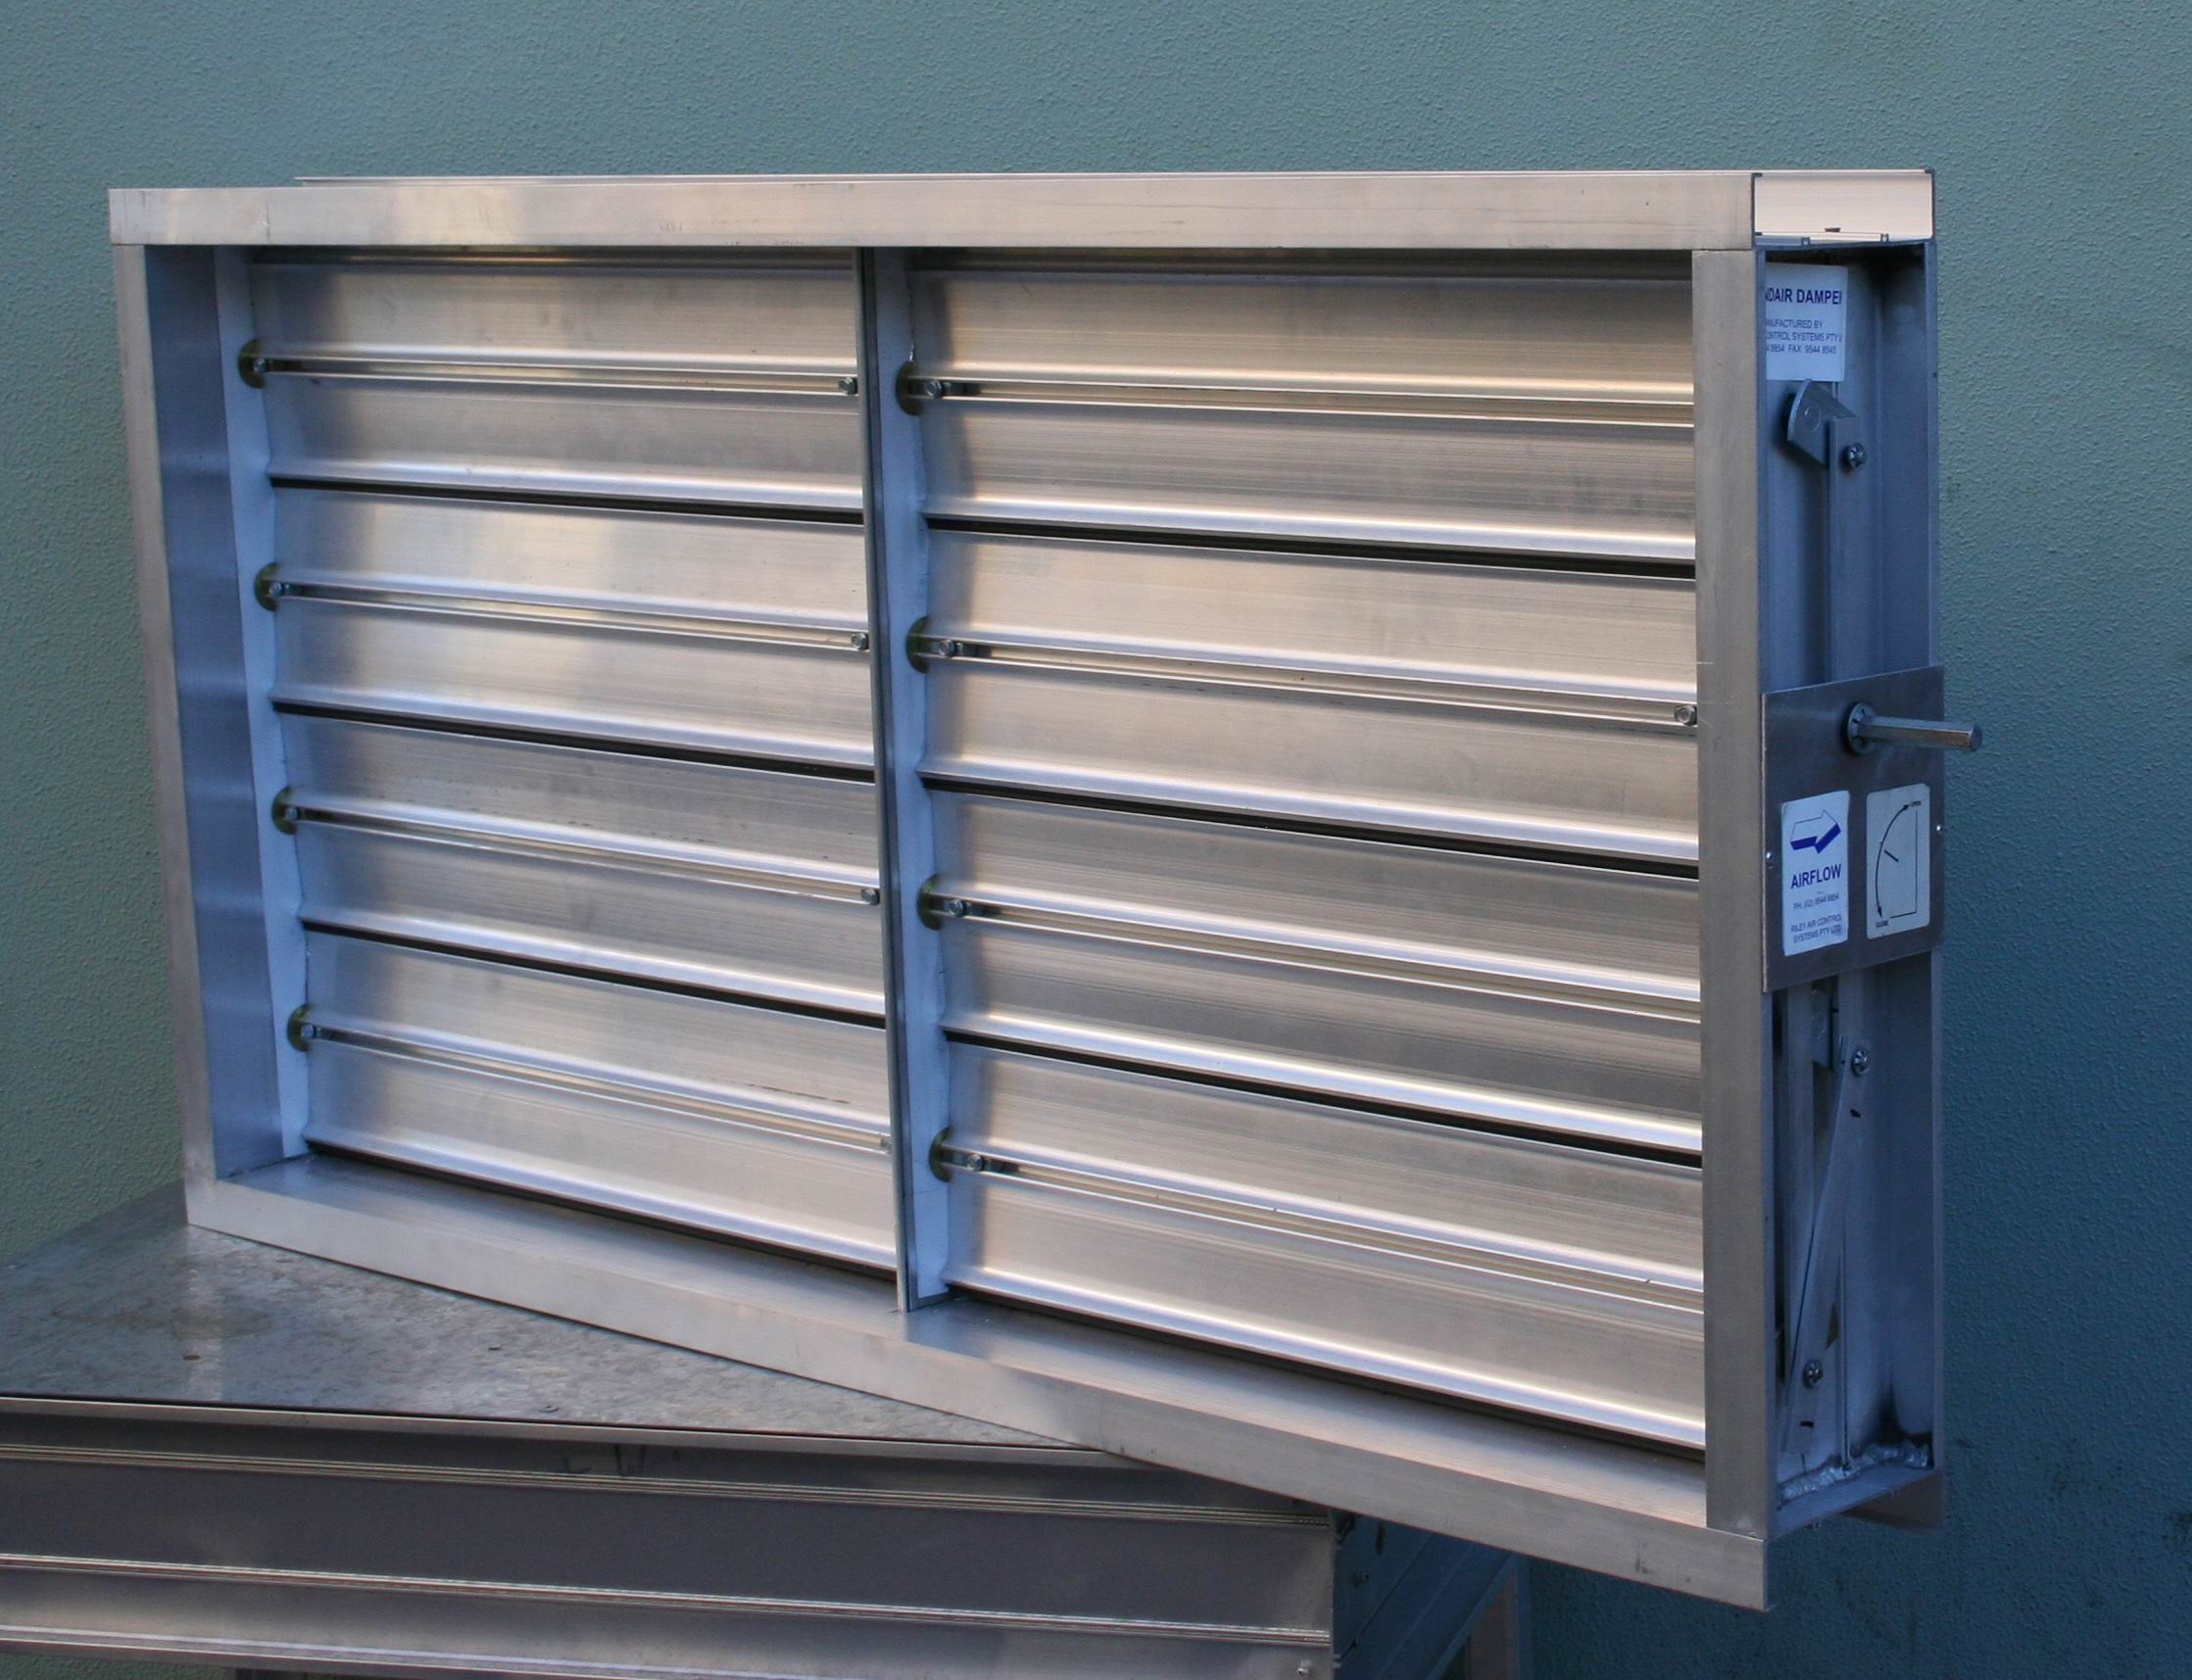

General

The VDA Series Aluminium Volume Control Dampers provide highly efficient airflow control in air handling systems. The VDA is a standard low leakage damper, available with ultra-low leakage feature (optional) and parallel or opposed blade configuration.

The damper frame, blades and linkages are made of Aluminium with minimum maintenance. Interlocking blades for reduced (LOW) leakage. Specially formed standard components and non-corrosive bearings conform to specifications required for high quality, low leakage, maximum rigidity and low operating torque. This allows the use of smaller or fewer actuators.

Multiple sections are inter-connected with a solid drive shaft and provide, together with individually adjustable internal blade linkages, a positive connection for optimum close-off sealing.

Total damper design and close manufacturing tolerances of Blendair dampers result in LONG DAMPER LIFE, SMOOTH & RELIABLE CONTROL and ENERGY SAVING.
Features

- Aluminium construction

- Linkages out of air stream

- Compatible ot duct flanging systems.

- Easier and faster installation.

- Precision control with less motors.

- Clip-on inflatable balloon seal (optional) allows field retro-fit

- Low leakage results in energy saving

VDA: VOLUME CONTROL DAMPERS

DESCRIPTION & FUNCTION
The VDA Series Volume Control Damper is a HIGH PERFORMANCE low leakage damper, which provides efficient airflow control in air handling systems .

The damper frame, blades and linkages are made of aluminium. Interlocking blade edges are the principle design features for low leakage. Low friction internal blade linkages and blade bearings ensure extra low torque and smooth and efficient modulating operation, it allows the use of smaller or fewer actuators.

Dampers are installed - as standard - with horizontal blade orientation. The opening, closing or modulation of the interconnected blades is effected by electric or pneumatic actuators initiated by control signals. Dampers are also available for manual control setting.

MODELS
- VDA: Low Leakage HIGH PERFORMANCE Aluminium Volume Control Damper for airflow control of air handling systems in corrosive atmosphere. Dampers are supplied with parallel or opposed blade configuration.

GUIDE SPECIFICATION (for the Engineer)
Volume Control Dampers installed for use in corrosive atmosphere or outside air application shall be of design and construction as the VDA Model supplied by Blendair, meeting requirements of LONG LIFE low leakage, extra low operating torque and smooth operation.

Frames shell be 3mm thick Aluminium of 6063-T5 alloy and blades shell be 2.5mm thick extruded Aluminium 6351-T5. Frames shall be recesses to hold side seal captive.

Blades shall be a single unit design up to 150mm wide with a hexagonal centre axis not to exceed 1200mm in length. Dampers over 1200mm in length must have a centre mullion support. The blade shall have a grooved insert to allow fitting of an inflatable PVC seal.
Each blade shall be mounted on an 11mm hexagonal zinc die cast crank arm which turns in a two piece captive nylon bush. All damper blades shall be interconnected by a non-corrosive bar linked for ganged operation. Blade linkage hardware shall be mounted within the extruded frame section and out of the air stream.
Interconnecting linkages shall have separate nylon bearings to minimise friction in the linkage.
Damper flanges shall be compatible with METU system, DUCTMATE, MEZ and angle iron flanges allowing for the use, where possible, of system centre joining clamps.

.DAMPER TYPES & APPLICATIONS
Dampers are supplied with two types of blade configuration:-
Parallel Blade Dampers are constructed so that each blade rotates in parallel with or in the same direction as the blade next to it. The rotation changes the direction of the airflow and can provide mixing and linear airflow characteristics, with only a small increase in airflow resistance.
Major control applications:
Return Air
Outdoor or Exhaust Air (w/o weather louvre or bird screen)
Bypass (w/o perforated baffle)
Two Positions or On/Off (all applications)
Outside Air
Opposed Blade Dampers are constructed so that adjacent blades rotate opposite to each other. The rotation does not change the direction of the airflow, but it does increase the airflow resistance as the air is funnelled through a smaller opening. Opposed blade dampers must be opened wider to obtain the same airflow as a parallel damper.

DAMPER ORDERING SPECIFICATION
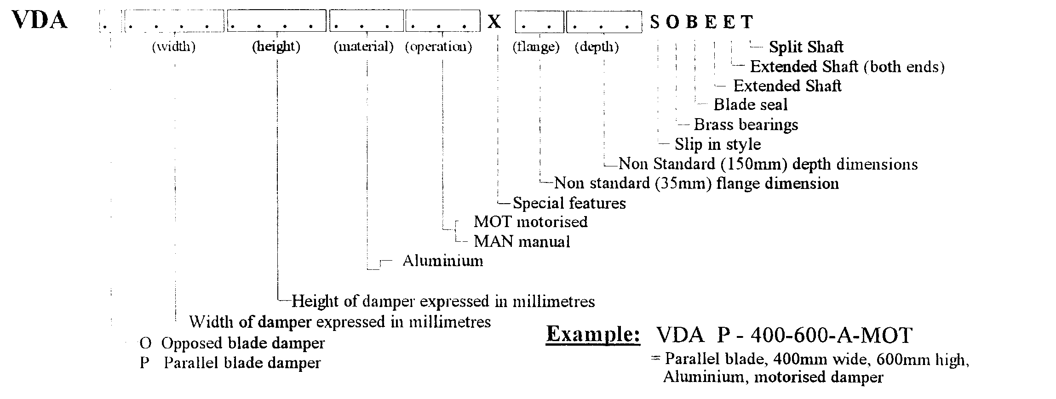

VDA: VOLUME CONTROL DAMPERS

DAMPER SIZING SPECIFICATION
Modules are supplied in the following standard sizes:
Single Module: from 150mm x 150mm (min)
to 1200mm x 2400mm (max)
Size Increment: 50mm
Multi Modules: available, for details refer to Riley Air Control System Pty. Ltd.
Note: . When specifying damper sizes (width and height), quote internal duct dimensions.

SPECIFICATIONS - Construction
Materials & Finishes:
- Damper frame and blades are manufacture Extruded Aluminium.

Damper Frame:
Standard Construction: Extruded Aluminium
Material Thickness: 3.0 mm

Blades:
Standard Construction: Extruded Aluminium

Material Thickness: 2.5 mm

Blade Seals:
Blade Ends: Aluminium continuous strips
(Side Seal)
Blade Edge: Clip-on, inflatable rubber

Blade Bearings:
Bearing Types: Two piece nylon held captive within frame.

Blade Axle & Drive Shaft:
Material: 11mm hexagonal zinc die cast crank arms

Drive Shaft: Drive Blade is fitted with hexagonal plated steel external motor mounting.

Manual Drive Hardware:
For manual operation, dampers are fitted with adjustable and lockable Quadrant and supplied without side seals.

Blade Linkage Hardware:
Linkage Bracket:Left & Right crank arms.

Linkage Connection Strip:

Blade Mounting Screws: 20mm x 3mm zinc plated steel

VDA: VOLUME CONTROL DAMPERS

Blade Orientation:
Dampers are available in two blade orientations (to be specified by customer): Parallel and Opposed.

SPECIFICATIONS - Technical
Maximum Pressure Differential:
1.5 kPa (6 Inch WC)
Maximum Approach Velocity:
20 m/sec (4000 fpm)
Temperature Range:
-40 to +93 degree C (in inflatable seal)

Leakage Characteristics On request.

INSTALLATION
Important! Improperly installed dampers prevent blades from sealing (see sketch below). Gaps between the blades and frame indicate that the damper is installed ‘out of square’ or ‘out of flat’. These misalignments will cause increased leakage and can result in blade-to-linkage bind or non-closure of blades, thus overloading the damper actuator or render it inoperative.

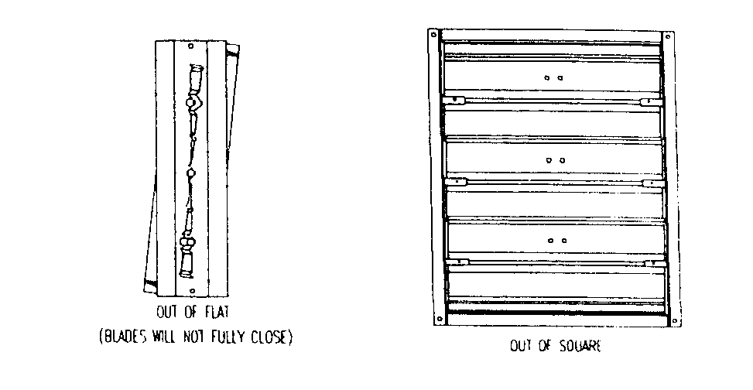

Installation Hints:
1. Always observe and follow instructions on label affixed to damper.
2. Before installation, ensure that damper is not damaged and blades operate freely.
3. Allow sufficient room on side of damper for mounting of actuator.
4. Install damper ‘square and flat’ as per warning above. Carry out final field adjustment to blade linkages, ensuring that all damper close tightly and tighten all sets-crews
5. Perform trial run of damper & actuator assembly, before attaching other end of duct work to damper.

Note: Do not fit damper near discharge or other turbulent areas.
OTHER DAMPER PRODUCTS
- Volume Control Dampers:
Low & Ultra Low Volume Control, Smoke Spill Damper, Min/Max Damper, Face & Bypass Damper, Zone Damper, Non-Return & Barometric Damper
- Fire Dampers:
Multi-Blade Fire Damper, Single Blade Fire Damper, Circular Fire Damper, Volume-Fire Damper, Ceiling Fire Damper, Curtain Fire Damper
- Sub Ducts
- Actuators & Damper Accessories:

Head Office: Riley Air Control Systems Pty. Ltd.
3/78-80 Bellingara Road
Miranda
Phone: (02) 9544 8854
Fax: (02) 9544 8545
Email: info@rileyair.com.au
A.C.N. 003 437 732

